HILLY FIELDS FOOTBALL CLUB
SEASON 31: 1997-98
Beckenham Hospital Veterans Cup
P W D L F A
1 0 0 1 0 2
Lewisham Hospital Veterans Cup
1 0 0 1 0 9
Friendly 31 9 3 19 65 113
TOTAL 33 9 3 21 65 124

Apps Gls Apps Gls
Sam Beattie 2 2 Mike Lane 1 0
Adrian Bennett 1 0 Shaun Litchfield 1 0
Mark Cooper 1 0 John Macrea 1 0
Alan Davies 1 1 Ray Marchant 1 1
Stuart Dyke 1 0 Steve Morton 4 9
Terry Dyke 1 0 Richard Patterson 1 1
Keith Farquahar 1 0 Tim Pike 1 1
Barry Fitzsimmons 5 5 Dave Plumb 10 14
Steve Ford 1 0 Steve Quinn 1 1
Keith Foster 1 0 Dave Radford 1 1
Paul Fowler 2 3 Mick Russell 2 2
Marc Glendenning 2 2 Charlie Shoppee 1 0
Ian Graver 1 0 Mick Spicknell 7 7
Chris Green 1 0 Ralph Stanton 1 0
Hainsley Henry 1 1 Albert St Clair 1 1
Eddie Hicken 1 0 Dick Stone 1 0
Mike Jefferys 1 0 Mario Vaz 2 3
Howard Jones 2 5 Dave Wright 1 0
Mark Jowitt 1 0 Chris Yusuf 1 0
John Kennedy 4 4 OG 1
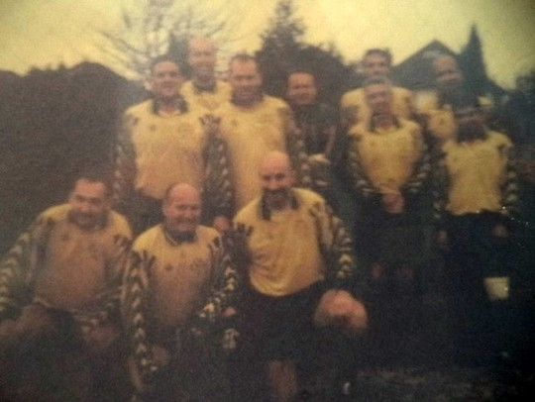
L-R Back: Keith Farquahar, Dave Radford, Barry Fitzsimmons, Mick Russell, Howard Jones, Dave Wright, Chris Yusuf, Mario Vaz
L-R Front: Mark Glendenning, Alan Davies, Mike Lane

